
Real-Time Priority Messaging System Using Amazon MQ

Sem End Project Report

Cloud Based Solution Architect

By

2300032555
B. Sai Lakshmi

Section-
Advanced/Peermentor

under the supervision of

Dr. S. Kavitha

Koneru Lakshmaiah Education Foundation
(Deemed to be University estd., u/s 3 of UGC Act 1956)
Green Fields, Vaddeswaram, Guntur (Dist.), Andhra Pradesh – 522302
April, 2026

CONTENTS

- Abstract 07
- Introduction 08
- Literature Review 11
- Project Objectives and Scope
  - Problem Statement 14
- Technical Implementation 17
  - Data Gathering 17
  - Creativity & Originality 18
- Analysis & Problem-Solving 20
- Discussions & Results 42
- Conclusion 49
- Future Work 51
- References 54

LIST OF FIGURES

Figure No | Title | Page  Number

Abstract
The Real-Time Priority Messaging System using Amazon MQ is designed to enable efficient, reliable, and asynchronous communication between distributed components in a cloud environment. In modern applications, handling large volumes of data and ensuring timely processing of critical information is essential. This project addresses these requirements by implementing a message-oriented middleware system where messages are transmitted through queues based on assigned priorities.
Amazon MQ, a fully managed message broker service, is used to simplify the setup and maintenance of the messaging infrastructure. The system consists of a producer application that generates and sends messages with different priority levels and a consumer application that retrieves and processes these messages in order of importance. The implementation is carried out using Java programming language along with ActiveMQ libraries, deployed on an Amazon EC2 instance.
The system ensures loose coupling between components, meaning that the sender and receiver do not need to interact directly. This improves scalability and fault tolerance. Additionally, the use of priority queues ensures that urgent tasks are handled before less critical ones, thereby improving system responsiveness and efficiency.
This project demonstrates the practical application of cloud computing and messaging systems in solving real-world problems such as delayed processing, system overload, and inefficient communication. It can be extended to various domains including banking systems, healthcare monitoring, notification services, and real-time data processing systems.

Introduction
With the rapid growth of distributed systems and cloud computing, the need for efficient communication mechanisms has become increasingly important. Traditional communication models, which rely on synchronous interactions, often lead to performance bottlenecks, tight coupling, and reduced system flexibility. These limitations make it difficult to scale applications and handle large volumes of data efficiently.
To overcome these challenges, message-oriented middleware (MOM) systems have been introduced. These systems allow applications to communicate asynchronously through message queues. In this approach, messages are sent to a queue by a producer and later retrieved by a consumer, enabling independent execution of different components. This decoupling improves system scalability, reliability, and maintainability.
This project focuses on implementing a Real-Time Priority Messaging System using Amazon MQ, a managed message broker service provided by AWS. Amazon MQ supports widely used messaging protocols and integrates seamlessly with applications developed in Java. By using this service, developers can avoid the complexity of managing their own messaging infrastructure.
The system follows a producer-consumer architecture. The producer sends messages with assigned priority levels, while the consumer processes them based on their importance. This ensures that high-priority messages are handled first, which is crucial in time-sensitive applications such as financial transactions, emergency alerts, and monitoring systems.
The project also utilizes Amazon EC2 to deploy and execute the Java-based applications. ActiveMQ libraries are used to implement messaging functionalities. This combination of cloud services and programming tools provides a scalable and efficient solution for real-time communication.
Overall, this project highlights the importance of asynchronous communication and priority-based processing in modern software systems, demonstrating how cloud technologies can be leveraged to build robust and efficient applications.

Literature Review
The concept of message-oriented middleware has been widely studied and implemented in distributed systems. Messaging systems such as Apache ActiveMQ, RabbitMQ, and Apache Kafka are commonly used to enable communication between different components of an application. Each of these systems has its own strengths and use cases.
ActiveMQ is one of the most popular open-source message brokers that supports multiple protocols and provides features such as message persistence, transactions, and security. RabbitMQ is known for its lightweight architecture and efficient message routing capabilities. Apache Kafka, on the other hand, is designed for high-throughput data streaming and is widely used in big data applications.
Amazon MQ is a managed messaging service that simplifies the deployment and management of message brokers. It supports both ActiveMQ and RabbitMQ engines, allowing developers to use familiar APIs and tools. Research indicates that managed services like Amazon MQ reduce operational complexity and improve system reliability by handling tasks such as maintenance, updates, and scaling automatically.
Priority-based messaging is another important concept discussed in the literature. In this approach, messages are assigned different priority levels, and the system processes them accordingly. Studies have shown that priority queues improve system efficiency by ensuring that critical tasks are completed first. This is particularly useful in real-time systems where delays can lead to significant issues.
Previous research also highlights the benefits of asynchronous communication, including reduced system dependency, improved fault tolerance, and better resource utilization. By decoupling system components, messaging systems enable independent scaling and easier maintenance.
This project builds upon these established concepts by implementing a real-time priority messaging system using Amazon MQ. It combines the advantages of cloud computing, message queuing, and priority-based processing to create an efficient and scalable communication system.

Project Objectives and Scope
Objectives
The primary objective of this project is to design and implement a real-time messaging system that can efficiently handle communication between distributed components. The system aims to demonstrate how Amazon MQ can be used as a reliable message broker for sending and receiving messages.
Another key objective is to implement the producer-consumer model using Java programming language. The producer is responsible for generating messages and assigning priority levels, while the consumer processes these messages based on their importance.
The project also aims to highlight the concept of priority-based message handling, which ensures that critical tasks are processed before less important ones. This improves system performance and responsiveness, especially in real-time applications.
Additionally, the project focuses on deploying the system on a cloud platform using Amazon EC2. This demonstrates the practical application of cloud computing in building scalable and distributed systems.
Finally, the project aims to provide a clear understanding of asynchronous communication and its advantages over traditional synchronous methods.
Scope
The scope of this project includes the design, development, and implementation of a real-time messaging system using Amazon MQ. It covers the setup of the message broker, development of producer and consumer applications, and testing of message transmission.
The system is designed to handle priority-based messaging, ensuring that important messages are processed first. It can be applied to various real-world scenarios such as notification systems, banking applications, and IoT-based monitoring systems.
However, the project is limited to a basic implementation and does not include advanced features such as distributed clustering, high-level security mechanisms, or large-scale data processing. These features can be added in future enhancements.
Problem Statement
In modern distributed systems, efficient communication between components is a major challenge. Traditional communication methods often rely on synchronous processing, where one component must wait for another to respond before continuing execution. This leads to delays, reduced system performance, and poor scalability.
Another issue is the lack of prioritization in message handling. In many systems, all tasks are treated equally, which can result in critical operations being delayed due to less important tasks. This is particularly problematic in real-time applications where timely processing of information is crucial.
Additionally, tightly coupled systems make it difficult to scale and maintain applications. Any failure in one component can affect the entire system, leading to reduced reliability.
To address these challenges, there is a need for a system that supports asynchronous communication, reduces dependency between components, and ensures efficient handling of tasks based on priority.
This project aims to solve these problems by implementing a Real-Time Priority Messaging System using Amazon MQ. The system allows messages to be sent and received independently, improving system flexibility and scalability. By introducing priority-based processing, it ensures that critical tasks are handled first, enhancing overall system efficiency and reliability.

Technical Implementation

Step-1: create Amazon MQ broker
As middle system to send and receive messages
Step-2: copy the broker url

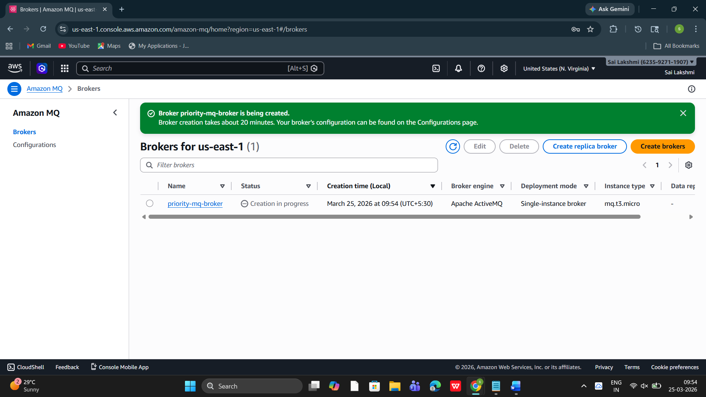

Step-3: Create EC2 instance for executing the java programs
Java programs—send and receive messages
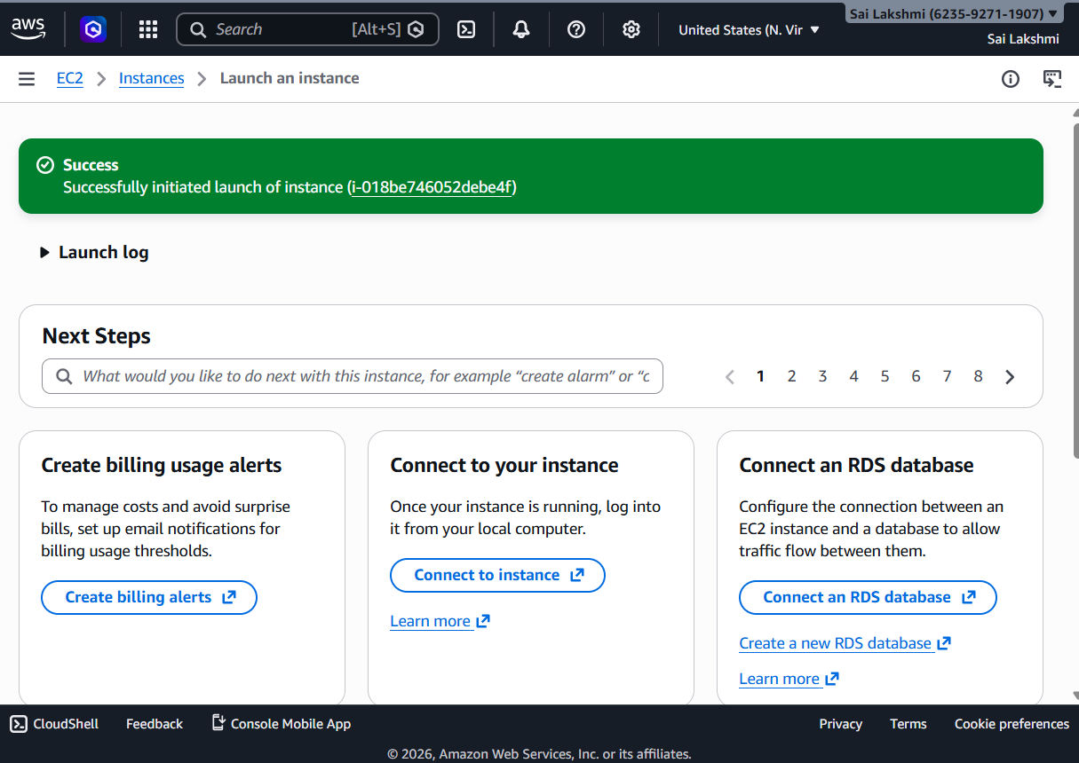
Step-4: open created EC2 and connect to the console

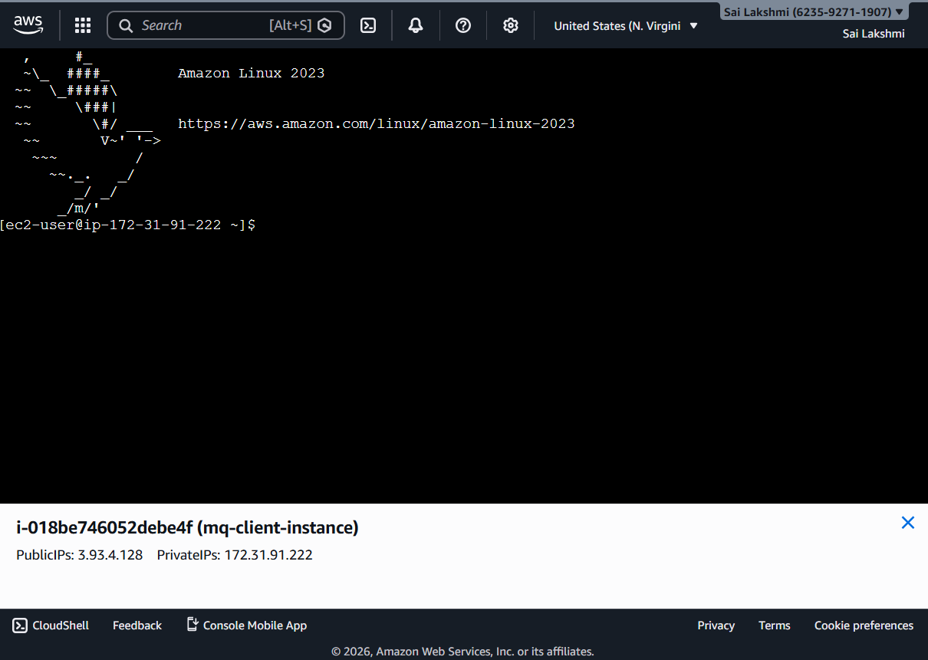

Step-5: Install java to download java programs
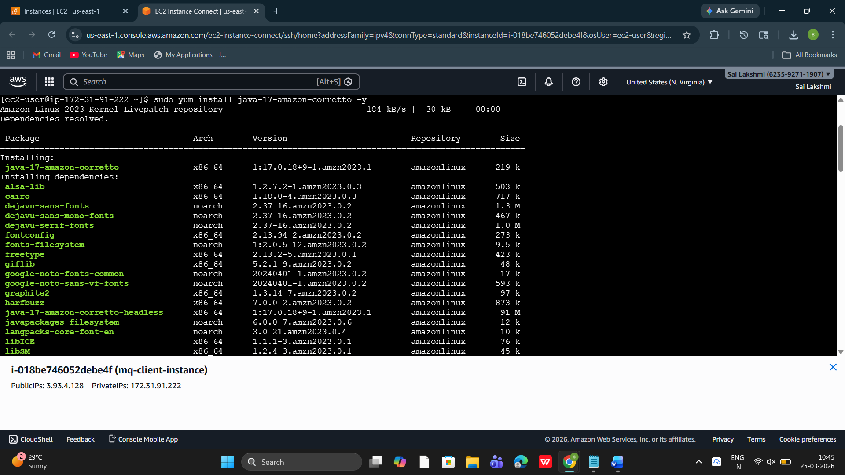

Step-6: Download ActiveMQ library to provide messaging functions
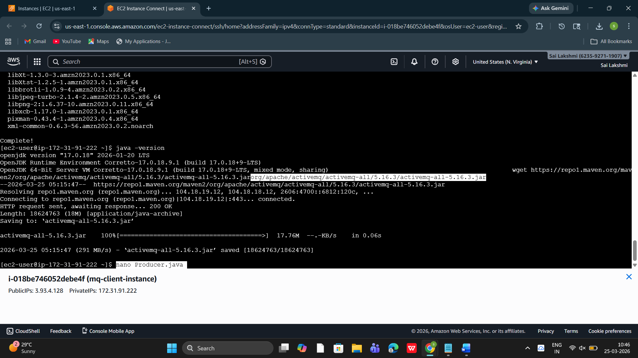

Step-7: give the producer(sender), consumer(receiver) codes
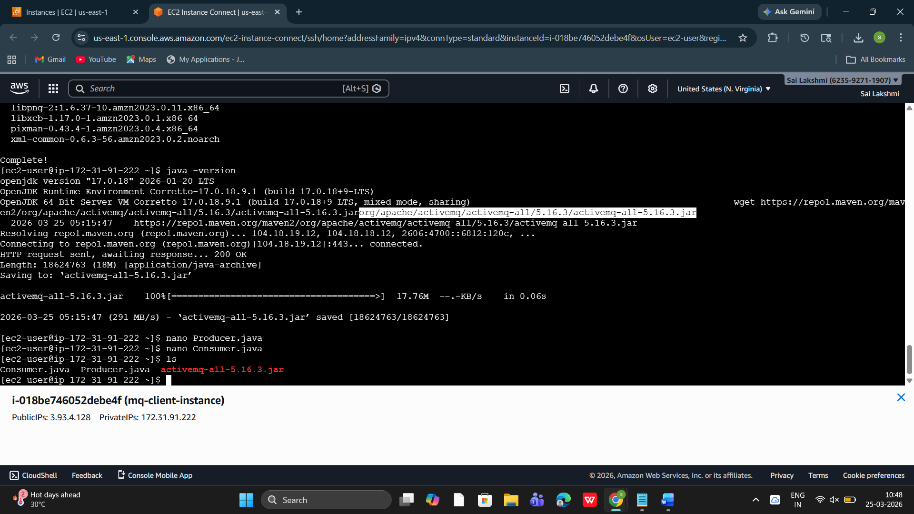

Step-8: check whether the codes are saved or not by using “ls” command
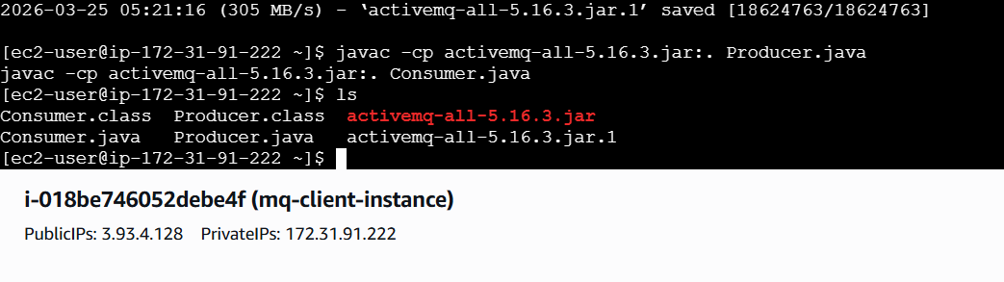

Step-9: Now execute the both producer and consumer codes to enable priority messaging.

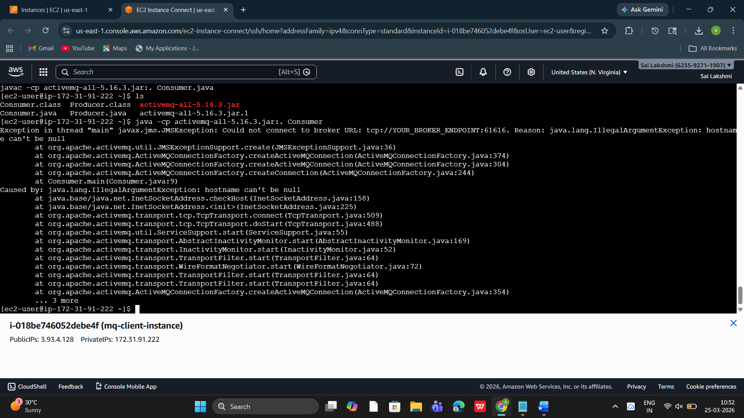

Consumer class output
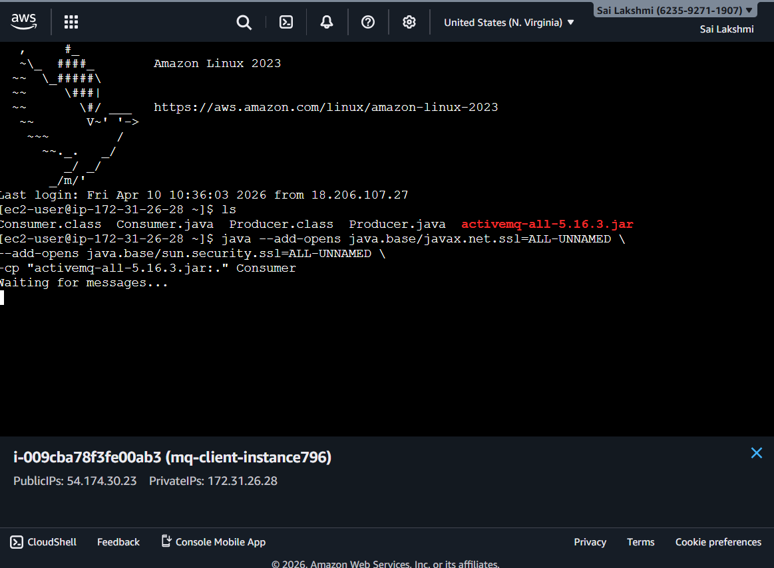

Producer class output
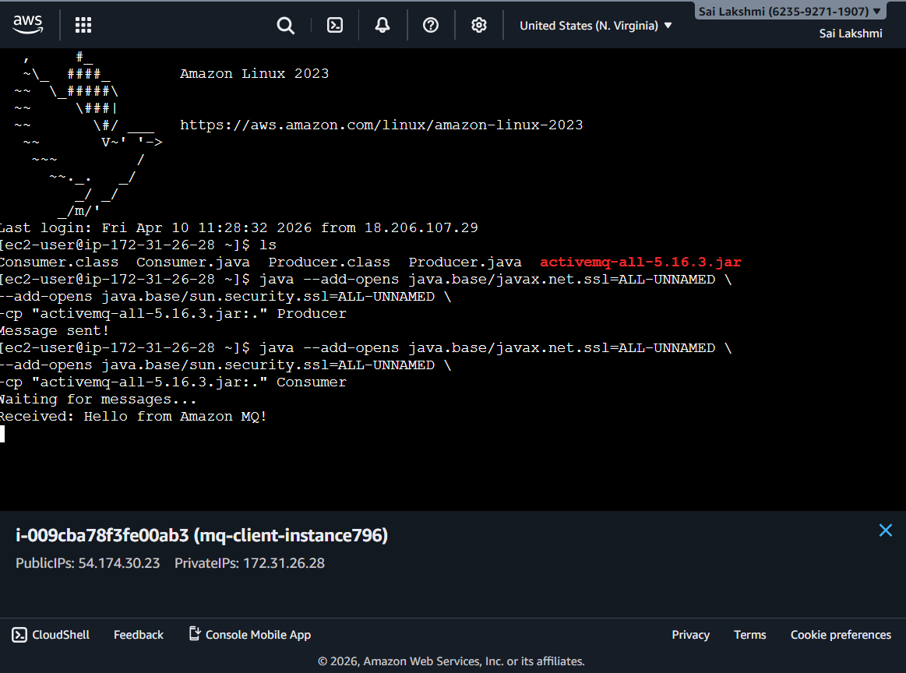

Data Gathering
Data gathering in this project primarily involves collecting configuration details and system requirements necessary for implementing the messaging system.
The first step involves gathering the Amazon MQ broker details, including the broker endpoint URL, port number, and authentication credentials. These details are essential for establishing a secure connection between the Java applications and the message broker.
Next, system-level data is collected from the EC2 instance, such as public IP address, instance type, and operating system configuration. This information is required to connect to the instance and execute the Java programs.
Additionally, the ActiveMQ library (JAR file) is downloaded, which provides the necessary APIs for implementing messaging functionalities. The Java source code for the producer and consumer is also prepared as part of the data required for execution.
The collected data ensures that all components of the system are properly configured and can communicate effectively. Proper data gathering is crucial for avoiding connection errors and ensuring smooth execution of the messaging system.

Creativity & Originality
This project demonstrates creativity and originality by integrating cloud-based messaging services with Java applications to build a real-time priority messaging system.
One of the key creative aspects is the implementation of priority-based message handling. Instead of processing messages in a simple first-in-first-out (FIFO) manner, the system assigns priority levels to messages, ensuring that critical tasks are handled first. This enhances system efficiency and responsiveness.
Another innovative aspect is the use of Amazon MQ as a managed service, which eliminates the need for manual setup and maintenance of message brokers. By combining this with EC2 and Java-based applications, the project showcases a practical approach to building scalable and distributed systems.
The project also demonstrates originality in its step-by-step implementation, including broker setup, cloud deployment, and real-time execution of messaging programs. It reflects a clear understanding of modern technologies such as cloud computing, message queuing, and asynchronous communication.
Overall, the project highlights a unique combination of concepts and tools to solve real-world communication challenges effectively.

Analysis & Problem-Solving
The analysis of the Real-Time Priority Messaging System focuses on evaluating the performance, reliability, and efficiency of message communication using Amazon MQ. The system was analyzed by observing how messages are transmitted between the producer and consumer under different conditions.
One of the key observations is that the use of asynchronous communication significantly improves system performance. The producer sends messages without waiting for the consumer, which reduces delays and increases throughput. This decoupling ensures that even if the consumer is temporarily unavailable, messages are stored in the queue and delivered later.
Another important aspect analyzed is priority-based message handling. Messages assigned with higher priority are processed before lower-priority messages. This ensures that critical tasks are executed first, which is essential in real-time systems such as alert mechanisms and financial applications.
During implementation, several challenges were encountered. These included connection issues with the Amazon MQ broker, configuration errors in the broker URL, and dependency-related errors such as missing ActiveMQ libraries. These problems were resolved by verifying the broker endpoint, ensuring proper installation of required libraries, and correcting the connection string format.
The system was also tested for reliability by sending multiple messages continuously. It was observed that the system handled the messages efficiently without data loss. This demonstrates the robustness of the messaging system.

Discussions & Results
The results of the project demonstrate the successful implementation of a real-time messaging system using Amazon MQ. The producer and consumer applications were able to communicate effectively through the message broker.
During execution, it was observed that messages sent by the producer were received by the consumer in a timely manner. The system maintained proper order based on priority, ensuring that high-priority messages were processed first. This validates the correctness of the priority messaging implementation.
The use of Amazon MQ as a managed service simplified the setup process and reduced the complexity of managing messaging infrastructure. The integration with EC2 allowed seamless execution of Java applications in a cloud environment.
The system also showed good scalability, as multiple messages could be handled without affecting performance. The results indicate that the system can be extended to handle larger workloads in real-world applications.
Additionally, the output screens confirm that the communication between producer and consumer is successful, and the system behaves as expected. The project demonstrates the practical applicability of cloud-based messaging systems in solving real-time communication problems.

Conclusion
The Real-Time Priority Messaging System using Amazon MQ has been successfully designed and implemented. The project demonstrates how cloud-based messaging services can be used to build efficient and scalable communication systems.
By implementing the producer-consumer model, the system achieves asynchronous communication, reducing dependency between components. The use of priority-based messaging ensures that critical tasks are handled first, improving system responsiveness and performance.
The integration of Amazon MQ, EC2, and Java technologies highlights the practical application of cloud computing in modern software development. The system is reliable, flexible, and capable of handling real-time communication effectively.
Overall, the project meets its objectives and provides a strong foundation for understanding message-oriented middleware and distributed systems.

Future Work
Although the project successfully implements a real-time priority messaging system, there are several areas for future improvement and enhancement.
One possible extension is the implementation of advanced security features such as encryption and authentication mechanisms to ensure secure message transmission. Another improvement could be the use of distributed clustering to enhance system scalability and fault tolerance.
The system can also be extended to support multiple producers and consumers, enabling it to handle large-scale applications. Integration with other AWS services such as Lambda, S3, or DynamoDB can further enhance functionality.
Additionally, implementing monitoring and logging mechanisms would help in analyzing system performance and detecting issues in real time.
Future work may also include developing a user-friendly interface for managing messages and monitoring system activity. These enhancements would make the system more robust and suitable for real-world enterprise applications.

References
- Amazon Web Services, Amazon MQ Developer Guide. Available at: https://docs.aws.amazon.com/amazon-mq/
- Apache Software Foundation, Apache ActiveMQ Documentation. Available at: https://activemq.apache.org/
- Oracle Corporation, Java Message Service (JMS) API Specification. Available at: https://docs.oracle.com/javaee/
- Amazon Web Services, Amazon EC2 User Guide. Available at: https://docs.aws.amazon.com/ec2/
- George Coulouris, Distributed Systems: Concepts and Design, Pearson Education
- Martin Fowler, Patterns of Enterprise Application Architecture, Addison-Wesley
- Research papers on Message Queuing Systems and Cloud Messaging (IEEE Xplore Digital Library)
- Oracle Corporation, Java SE Documentation. Available at: https://www.oracle.com/java/

